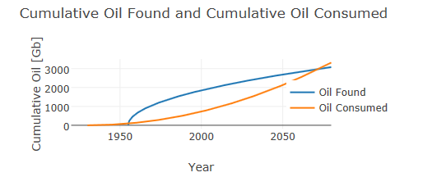

These two functions meet around the year 2070. At that time, we will have consumed (used or whatever you oil people want to call it) all the oil that we have found. After that year we will have a higher demand for oil than we can find it. So, in 2070 bad things happen if we are using oil at the same increasing rate that we are using it now. Remember, this is a crude oil model for the oil “found” and oil “used”.

http://www.wired.com/2015/02/infinite-amount-oil-enough/